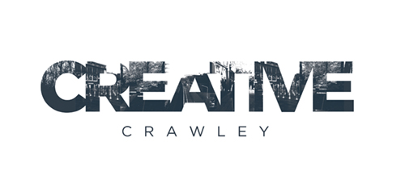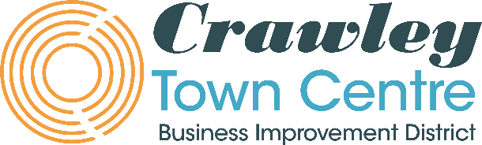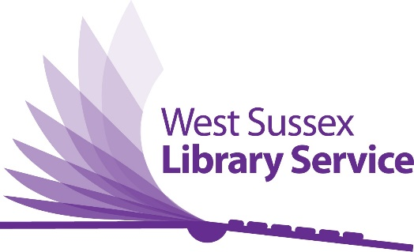
Illustrator brief - Enliven: Crawley’s Future Through Young Eyes
Lookout Mural
The Project
Lookout is a performance which takes place as an encounter between one child performer and one adult audience member, standing together overlooking Crawley. The interaction is led by the young performer and focuses on the future of the town in which we live. The performance will take place in a venue overlooking Crawley town centre on 28th - 30th April as part of Creative Crawley and Crawley Town Centre Business Improvement District’s Enliven cultural programme.

Preparation for the performances involves a series of workshops with Year 5 students from Seymour Primary School in Broadfield, Crawley. The group will imagine what the future of Crawley might be, exploring topics such as architecture and urban planning, changing technology and the changing environment, politics, community and science fiction.

The performance involves each of these young performers sharing their vision of the future with audience members through a series of supervised 20 minute one-to-one conversations.

Lookout has taken place around the UK and internationally over the last 7 years. In each location for Lookout, the artists Andy and Beckie commission a local illustrator to listen to the children’s descriptions of the future town and create a drawing imagining how that town will look. This drawing is used as the front of the programme and copies of it are given to the children as a thank you for their participation. For the Crawley version this drawing will also be painted permanently on a currently blank wall at Crawley Library in Crawley town centre.

The brief
Creative Crawley, Crawley Town Centre BID, Crawley Library and Andy and Beckie are looking for an illustrator to design an image based on listening to the children involved in the project and then reflecting their future vision of Crawley in the art work.

The image will be painted onto a wall (either by the original artist or in collaboration with someone else) in Crawley library and be a permanent fixture. It will also be used on the programme for the show. The wall in the library is 2.5m wide and 1.9m high.

The Artists
Andy Field and Beckie Darlington are artists based in London. They collaborate with young people to create innovative projects that aim to initiate intergenerational dialogue and new, more radical modes of civic participation. Their work is based in performance but has taken a range of forms, from an underground social-action collective of school children in St Helens to rooftop conversations about the future between adults and children in Cairo, Sao Paulo and Beijing, and from a local TV news network run entirely by children to a chat show for microbes. www.andyandbeckie.co.uk

The Producers and Funders
Creative Crawley is a brand new charity whose Trustees represent a range of local stakeholders who aim to place creativity at the heart of Crawley and support, develop and produce high quality arts and culture in the town.

Crawley Town Centre BID is the dedicated Business Improvement District for Crawley Town Centre working with and for the businesses collaborating to deliver a thriving town centre where people want to be.

The Enliven programme is a year round series of artworks, performances, workshops and creative experiences which aims to bring Crawley town centre to life through arts and culture. Funded by Crawley Town Centre BID and produced by Creative Crawley.

Schedule and Fee

w/c 4th April: The first week of workshops with the students takes place
Friday 8th April: A selection of recordings from the children will be ready to send to the illustrator and then work can begin on the illustration.
Friday 15th April: First draft of the illustration to be shared. Then there will be a process of feedback from the partners (this will be light touch) .
Friday 22 April: Final illustration confirmed so that the illustration can be printed for the programme and painted on to the wall at Crawley Library.
Thurs 28th April: Painting installed on the wall. Pencilled dates for painting are 25th – 27th April.
The fee: £800 for the equivalent of approximately 4 days’ work. Materials and fee for painting the wall with the mural are in addition to this fee. This is a freelance position and the successful applicant will need to have proof of self-employed status.
Person specification
At least 2 years professional illustration experience
Desired:
Experience of working with young people
Experience of working in the public realm
We will prioritise applications from people based in Crawley and the South East of England but will accept applications from artists based anywhere in the UK.
Application process
Please send a link to your work plus CV and a one page A4 letter outlining why you are interested in the job, what relevant experience you have and what connections you have to Crawley (if any).
Email this information to hello@creativecrawley.com by Weds 9th March 2022. Informal interviews will take place w/c 21 March. NB these dates have been updated from the original brief due to staff absence.
If you would like to have an informal conversation about the brief before 23rd February, please email hello@creativecrawley.com to arrange a time.

