Community Producer 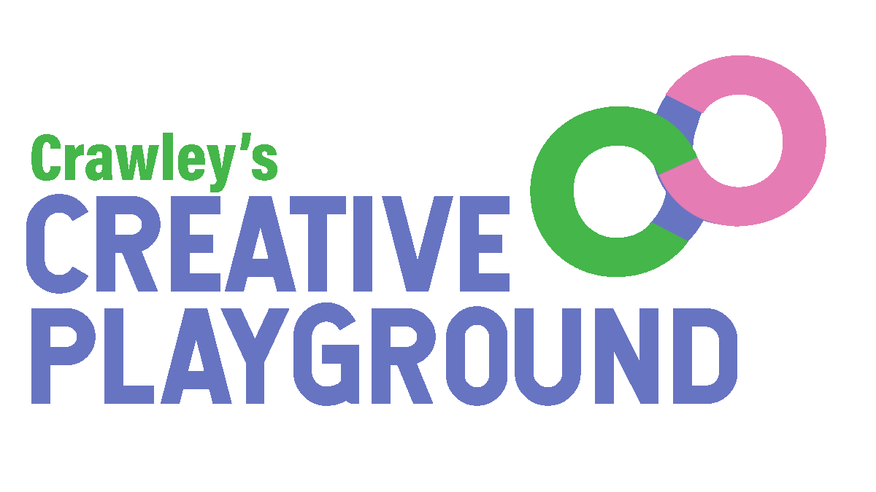
Creative Playground (Creative People and Places) Programme

Job Description

Accountable to: Project Co-Directors, Creative Playground
Responsible to: Head of Learning and Production, Creative Playground
Responsible for: Communications and Admin Assistant
Employer: Creative Crawley

TERMS OF CONTRACT:
- Contract start date: 3rd April 2023
- Contract end date: March 2025 subject to satisfactory 6-monthly reviews throughout the course of the contract, and continuation of ACE funding
- 3 days (24 hours) per week
- PAYE or freelance
- Rate of pay: ££30,000 - £32,000 per annum pro rata
- To be paid monthly in arrears
- Probationary period: 6 months
- Period of notice: 2 months
- Place of work: The post will be based within Creative Playground offices and other suitable locations across Crawley

References will be taken up prior to contract commencement
You will be expected to work flexibly which will include some evenings and weekends.
No overtime will be paid but the organisation operates a Time Off In Lieu policy and procedure.
___________________________________________________________________________

Introduction

Creative Playground is a project funded by the Arts Council England Creative People and Places programme from 2022 to 2025.
It is a new project in Crawley that encourages local people to lead a programme of arts and culture and engage in high quality arts and culture in their town as audiences, participants, makers, producers and curators. Local people work with a team of experts to develop their skills, engage in a wide range of different types of creativity and make decisions about what art and culture takes place in their town in homes, work places, community venues, outdoor areas and public spaces.
Playmakers is a network of Crawley people who come together to take part in and help make decisions on what cultural activity happens in their local area.
Creative Playground is managed by a consortium made up of the following organisations: Manor Royal BID, The Hawth, LGBT+ Crawley, DIVERSECrawley and Crawley Town FC Community Foundation.
The aims are:

- To achieve a long-term increase in levels of arts engagement
- To increase the types of decisions that residents can make regarding creative activities happening in their town, and involve them in direct decision-making for the project.
- To bring more resources into the area for creative projects.
- To leave a stronger local arts infrastructure and cultural offer.
- To have a positive effect on community cohesion and wellbeing.
- To develop the reputation of Crawley as a cultural destination where you can see and take part in a wide range of high quality creative events and activities.

Principal Aims of the Job:

The Community Producer is responsible for the programme management of Creative Playground, Crawley’s Creative People and Places Programme. In collaboration with the Project Co-Directors and Head of Learning and Production, and in collaboration with the Community Engagement Manager, the Community Producer will manage all aspects of the programme and support the strategic development, deliver against the business plan and work towards the key milestones, targets and outcomes agreed.

Key Responsibilities:

- Producing, Commissioning and Developing
- Co-produce arts and cultural events for and with local people, stakeholders and sector partners
- With the Project Co-Directors and Creative Playground team, identify appropriate and inspirational professional artists and creative projects to contribute to the Programme through collaboration and co-decision-making with the Playmakers.
- Be equipped with a strong network of contacts in the arts, including outdoors arts, festivals and participatory practice
- Develop a robust network of sector contacts and expertise to effectively profile the programme and its outcomes
- Maintain current and develop new strategic partnerships at a local, regional and national level
- Maintain an up to date knowledge and interest in developments taking place in the local voluntary, statutory and arts sectors
- Contract artists and creative projects for Creative Playground. This will include:
  - Preparing commissioning packs
  - Writing briefs in collaboration
  - Co-ordinating decision-making panels
  - Working with the team to ensure that local residents and other local stakeholders are able to make well-informed decisions

- Programme Management
- Collaborate with the Community Engagement Manager to manage the current programme in the context of the 10 year vision
- Identify gaps in provision and geographical focuses within the programme

- Production
- Work with the Head of Learning and Production to ensure all projects are delivered on time, on budget and in a safe and accessible manner.
- Identify and allocate resources (both human and physical) across the creative programme
- Deliver and manage a series of events across the life cycle of the programme, taking into account the requirements of the target audiences
- Implement the Safeguarding Policy for the Protection of Children, Young People and Vulnerable Adults, and other key policies such as Health and Safety, Equal Opportunities and Intellectual Property Rights

- Volunteers, Playmakers and the Public
- Champion the ethical and transparent selection process that is at the heart of this programme
- Ensure all programming and community engagement activity meets the requirements of the engagement framework

- Communications
- Manage the Communications and Admin Assistant and freelance teams
- Support the Project Co-Directors, Community Engagement Manager in developing and implementing strong marketing and audience development initiatives for the programme
- Fully subscribe to the ethos of collaboration that is at the heart of this programme
- Facilitate participatory decision-making in all our artist commissioning
- Support the Creative Playground Communications and Admin Assistant in developing and implementing communications initiatives for the programme. These will include:
  - Internal updates
  - Team meetings
  - Briefings
  - Advocacy events and papers
  - Programme Launch events
  - Printed materials
- Supply content on a weekly basis
- Be active and present in all Creative Playground social media channels

- Monitoring and Evaluation
- To ensure that the programme’s external evaluators have 360 degree access to the programme
- Work with the Project Co-Directors and Evaluation Assistant to ensure that evaluation and monitoring is embedded across the programme
- Support the completion of the monitoring and evaluation reports for Arts Council England
- Ensure that all commissioned groups provide monitoring and evaluation reports in a timely manner and that feedback informs the development of the programme

- Income generation and Financial Management
- Support the sound financial management of the programme as appropriate, including contributing to forecasting, and the preparation of management and audited accounts as required
- Manage and oversee project budget activity across the commissioning programme
- Contribute to business development and income generation through the creation of new fundraising initiatives and partnerships
- Support Project Co-Directors with the developing and delivering of presentations, bids and tenders to potential funders and partners
- Contribute to funding applications to grant giving Trusts and Foundations and Public Bodies.
- Maintain and develop excellent funding relationships with key contacts.
- Maintain awareness of local, regional and national arts and participation funding opportunities.
- Complete the financial monitoring information report for ACE

- Governance
- Attend Core Consortium meetings as required, providing regular programme update reports
- Manage the Communications and Admin Assistant and freelance teams

- Other
- Work to the programme’s Code of Conduct
- Any other duties as reasonably required by the Project Co-Directors

Community Producer: PERSON SPECIFICATION

The person specification is provided to help you in writing your application and gives the minimum experience, skills, abilities and qualities required by Creative Playground for this position.

Essential
- A minimum of 3 years experience in a similar role
- Proven experience of working with artists and projects that place participation and/or co-creation at the heart of their practice.
- Experience of strategic programme management and delivery and of developing large-scale, sustainable programmes of work
- The ability to communicate with participants who have limited experience of the arts
- Experience of commissioning and funding models
- Well developed creative skills, with the ability to think laterally and innovatively
- Proven experience of developing strategic partnerships at a range of levels within the arts, statutory and community and voluntary sectors
- Experience of working with a range of organisations, groups and individuals and communicating effectively at all levels
- Experience of the management of and control of budgets
- Excellent networking and advocacy skills
- Marketing and communications experience
- An awareness of equal opportunities policy and practice and a commitment to inclusion and access.
- The ability to prioritize, working on own initiative and in a flexible and responsive manner
- Experience of monitoring, evaluation and report writing
- High level of presentation and communication skills in written and verbal forms including excellent ICT literacy
- Vision, ambition and enthusiasm for the long-term development of Creative People and Places
- Willingness to undertake an enhanced criminal records disclosure

Desirable
- Knowledge of Crawley and the wider region’s creative ecology.
- Clean driving license

How to apply
The Consortium is committed to equality of opportunity and access for all. We recognise the positive value of diversity and promote equality. We welcome and encourage applications from everyone, irrespective of their age, gender, class, marital status, nationality, ethnic origin, disability, religious belief or sexual orientation or any other protected characteristics listed under the Equality Act.
To apply, please submit:
A letter of application setting out why you are applying, your interest in the position, and how your skills and experience match the job description and ideal candidate specification (maximum 1,000 words) • Details of 2 referees, one being your current or most recent employer • Your Curriculum Vitae
Please also complete this equality monitoring form with your application: https://forms.gle/3gBczMf3mDQuf2nB9
All applications must be submitted to Creative Crawley by 12 noon Monday 6 March 2023 via email to recruitment@creativeplaygroundcrawley.com . Applications can be submitted in alternative formats on request – please contact recruitment@creativeplaygroundcrawley.com
For an informal conversation about the role please contact louise@creativeplaygroundcrawley.com
Shortlisted applicants will be contacted by Friday 10th March and invited for interview on 15 or 16 March 2023. Interviews will be held online or at an address to be confirmed in Crawley.
An offer will be made to the successful candidate shortly after this. Candidates should note that any offer of employment made by Creative Crawley will be subject to satisfactory written references and possibly a Disclosure and Barring Service check. Candidates must also be able to demonstrate that they have the right to work in the UK and that they have the qualifications listed in their application. You are always advised not to resign from your present employment until any offer of employment has been confirmed.

