Head of Learning and Production 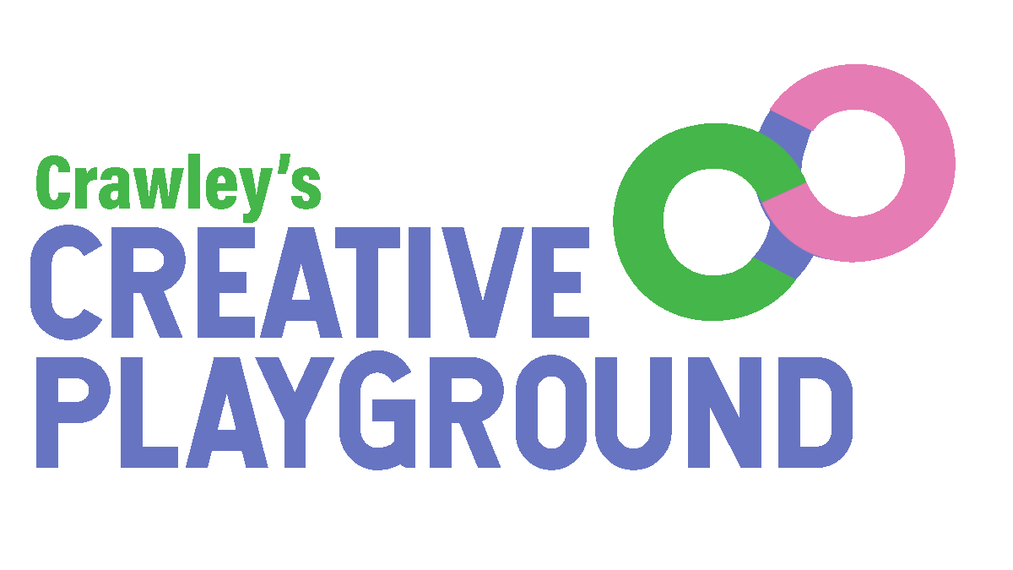
Creative Playground (Creative People and Places) Programme

Job Description

Accountable to: Project Co-Directors, Creative Playground
Responsible for: Community Producer, Community Engagement Manager

TERMS OF CONTRACT:
- Contract start date: 3rd April 2023
- Contract end date: March 2025 subject to satisfactory 6-monthly reviews throughout the course of the contract, and continuation of ACE funding
- 4 days (32 hours) per week
- PAYE or freelance
- Rate of pay: £38,000-£40,000 per annum pro rata
- To be paid monthly in arrears
- Probationary period: 6 months
- Period of notice: 2 months
- Place of work: The post will be based within a workplace location in Crawley to be confirmed and other suitable locations across Crawley

References will be taken up prior to contract commencement
You will be expected to work flexibly which will include some evenings and weekends.
___________________________________________________________________________

Introduction

Creative Playground is a project funded by the Arts Council England Creative People and Places programme from 2022 to 2025.
It is a new project in Crawley that encourages local people to lead a programme of arts and culture and engage in high quality arts and culture in their town as audiences, participants, makers, producers and curators. Local people work with a team of experts to develop their skills, engage in a wide range of different types of creativity and make decisions about what art and culture takes place in their town in homes, work places, community venues, outdoor areas and public spaces.
Playmakers is a network of Crawley people who come together to take part in and help make decisions on what cultural activity happens in their local area.
Creative Playground is managed by a consortium made up of the following organisations: Manor Royal BID, The Hawth, LGBT+ Crawley, DIVERSECrawley and Crawley Town FC Community Foundation.

The aims are:
- To achieve a long-term increase in levels of arts engagement
- To increase the types of decisions that residents can make regarding creative activities happening in their town, and involve them in direct decision-making for the project.
- To bring more resources into the area for creative projects.
- To leave a stronger local arts infrastructure and cultural offer.
- To have a positive effect on community cohesion and wellbeing.
- To develop the reputation of Crawley as a cultural destination where you can see and take part in a wide range of high quality creative events and activities.

Principal Aims of the Job:

The Head of Learning and Production is responsible for two key areas of the Creative Playground programme; a) Ensure training and learning is at the heart of the programme; b) Production Management of all events and activities.

In collaboration with the Project Co-Directors and the rest of the team, the Head of Learning and Production will oversee all aspects of the programme and support the strategic development and deliver against the business plan and work towards the key milestones, targets and outcomes agreed.

Key Responsibilities:

- Training and learning
- Develop, embed and lead on the creation and implementation of a learning programme for local people as part of the Creative Playground, creating opportunities to share best practice, offer local skills development and create a sound legacy for Creative Playground in Crawley
- Enable those that may not have considered the arts is for them to be inspired by and learn new skills to support their engagement in the creative ecology of Crawley
- To devise and deliver a community engagement training programme in line with the engagement strategy and supporting the learning of everyone participating
- Respond to the learning needs of all participants and work in partnership with key providers to deliver a meaningful skills development programme.
- Ensure all participants (staff, volunteers, participants and other stakeholders) have access to learning opportunities
- Manage strategic, developmental partnerships enhancing the values of the programme
- Collaborate with the Community Engagement Manager to deliver the engagement strategy.

- Production
- Be responsible for all production elements of the programme including:
  - Enabling artists & participants to achieve their ambitions in a safe way and to the best of their ability
  - Enabling a wide range of audiences to experience and participate in the programme in a safe and dynamic way
  - Collaborating with creative workers to devise and create innovative solutions to production needs
  - Working with local and regional suppliers to enable best value for the budget
  - Ensuring all spaces that are utilised for Creative Playground events are clean, safe and appropriate for the activity proposed
  - Ensuring all technical needs for programme activity are met
  - Being responsible for ensuring all projects are delivered on time, on budget and in a safe and accessible manner.
- Provide strong, inspirational and ambitious production management for all aspects of the programme ensuring training is embedded into all technical aspects of creation, production and presentation of programme elements of Creative Playground.
- Work collaboratively with key stakeholders to encourage the sharing of resources, minimising transport and the impact on the environment.
- Recruit and manage additional members of the Production team including volunteers as necessary.
- Draw up all Event Plans, Method Statements and Risk Assessments relating to the programme.
- Realise the technical requirements of each event in the programme and liaise with the programmed artists in a timely fashion
- Oversee the maintenance and procurement of Creative Playground equipment
- Ensure all productions, exhibitions, workshops and other events in the programme are managed to a high standard and that the programme complies with all health and safety, safeguarding and other policies relating to the safety of the audience, staff and participants.
- Be responsible for ensuring all activities comply with disability legislation and that our programme is open to and available for as wide a range of people as possible.
- Manage the Community Producer
- Maintain the Safeguarding Policy for the Protection of Children, Young People and Vulnerable Adults, and other key policies such as Health and Safety, Equal Opportunities and Intellectual Property Rights
- Become the designated safeguarding lead for the programme

3. Producing and commissioning
● Facilitate participatory decision-making in all programme delivery.

- Strategic Development
- Develop a robust network of local and sector contacts and expertise to effectively profile the programme and its outcomes
- Maintain an up to date knowledge and interest in developments taking place in the local voluntary, statutory and arts sectors

4. Communications
- Support the Project Co-Directors, Community Engagement Manager and Community Producer in developing and implementing strong marketing and audience development initiatives for the programme
- Fully subscribe to the ethos of collaboration that is at the heart of this programme
- Facilitate participatory decision-making in all our artist commissioning
- Supply content for the progranmme’s social channels and website on a regular basis

5. Monitoring and Evaluation
- Work with the Project Co-Directors to ensure that evaluation and monitoring is embedded across the programme
- Embrace the Creative Playground as an action research programme, embedding learning in response to feedback on a regular basis.
- Support the completion of the monitoring and evaluation reports for Arts Council England
- Ensure all contributors to the programme provide monitoring and evaluation reports in a timely manner and that feedback informs the development of the programme

6. Income generation and Financial Management
- Support the sound financial management of the programme as appropriate, including contributing to forecasting, and the preparation of management and audited accounts as required
- Reconcile the production budgets on a quarterly basis and contribute to the delivery of the annual accounts.
- Manage the production & learning budget for the programme
- Contribute to business development and income generation through supporting the creation of new fundraising initiatives and partnerships
- Support Project Co-Directors with the developing and delivering of presentations, bids and tenders to potential funders and partners

7. Governance
- Attend Core Consortium meetings as required, providing regular programme update reports
- Line manage the Community Producer through mutually agreed catch ups and appraisals
- Deputise for the Project Co-Directors when necessary.

8. Other
- Work to the programme’s Code of Conduct
- Any other duties as reasonably required by the Project Co-Directors
- To work flexibly, including at least 1 evening a week, and at least 1 weekend a month

Head of Learning and Production: PERSON SPECIFICATION

The person specification is provided to help you in writing your application and gives the minimum experience, skills, abilities and qualities required by Creative Playground for this position.

Essential
- A minimum of 3 years experience in a Production role in a venue and/or with a range of arts organisations
- Demonstrable technical and logistical skills necessary for realising a community facing programme
- Experience of embedding training and learning into a core arts programme
- Proven experience of working with artists and projects that place participation and/or co-creation at the heart of their practice.
- Experience of strategic programme management and delivery and of developing large-scale, sustainable programmes of work
- An excellent understanding of and experience in preparing Event Plans, Method Statements and Risk Assessments for small, medium and large scale projects.
- Proven experience of the legal requirements of the production aspects of a programme like Creative Playground
- The ability to communicate with participants who have limited experience of the arts
- Well developed creative skills, with the ability to think laterally and innovatively
- Experience of working with a range of organisations, groups and individuals and communicating effectively at all levels
- Experience of the management of and control of budgets
- Excellent networking and advocacy skills
- An awareness of equal opportunities policy and practice and a commitment to inclusion and access
- The ability to prioritize, working on own initiative and in a flexible and responsive manner
- Vision, ambition and enthusiasm for the long-term development of Creative People and Places
- Willingness to undertake an enhanced criminal records disclosure

Desirable
- Knowledge of Crawley and the wider region’s creative ecology.
- Knowledge of marketing and communication strategies.
- Clean driving license

How to apply
The Consortium is committed to equality of opportunity and access for all. We recognise the positive value of diversity and promote equality. We welcome and encourage applications from everyone, irrespective of their age, gender, class, marital status, nationality, ethnic origin, disability, religious belief or sexual orientation or any other protected characteristics listed under the Equality Act.
To apply, please submit:
A letter of application setting out why you are applying, your interest in the position, and how your skills and experience match the job description and ideal candidate specification (maximum 1,000 words) • Details of 2 referees, one being your current or most recent employer • Your Curriculum Vitae
Please also complete this equality monitoring form with your application: https://forms.gle/3gBczMf3mDQuf2nB9
All applications must be submitted to Creative Crawley by 12 noon Monday 6 March 2023 via email to recruitment@creativeplaygroundcrawley.com . Applications can be submitted in alternative formats on request – please contact recruitment@creativeplaygroundcrawley.com
For an informal conversation about the role please contact louise@creativeplaygroundcrawley.com
Shortlisted applicants will be contacted by Friday 10th March and invited for interview on 15 or 16 March 2023. Interviews will be held online or at an address to be confirmed in Crawley.
An offer will be made to the successful candidate shortly after this. Candidates should note that any offer of employment made by Creative Crawley will be subject to satisfactory written references and possibly a Disclosure and Barring Service check. Candidates must also be able to demonstrate that they have the right to work in the UK and that they have the qualifications listed in their application. You are always advised not to resign from your present employment until any offer of employment has been confirmed.

